September 2012

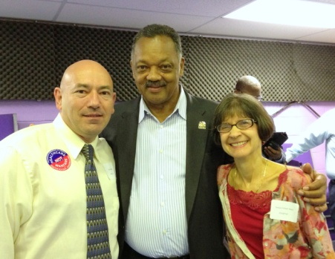
As an alternative to the Democratic National Convention the Progressive Democrats of America (PDA), an amalgam of activists who feel the Democratic Party has been coopted and lost its way, held an event Sept 3rd that Dr. Keely and Mr. Ball attended. During that time we got to strategize with Dr. Jessica Saxe from the North Carolina chapter. It was gratifying to hear Rev Jesse Jackson proclaim that he was dedicated to Single Payer. There were a number of leaders in the healthcare reform movement in attendance. Labor was well represented as were politicians, advocacy groups, and a number of delegates to the DNC. Considering the high profile guests (Conyers, Dukakis, Jackson, and others) the audience was rather small – perhaps 100 people. What they lacked in numbers they made up with enthusiasm. Dr. Quinton Young was scheduled to attend but cancelled at the last moment for health reasons.
INSIDE – Dr. Gray requested membership pamphlets to send out to her colleagues. Dr. Perez and Dr. McTigue agreed to host the next HCFA-SC meeting and are working on finding a venue. We were on both the Progressive Democrats of America (PDA) and PNHP national conference calls. Media contact representatives are now listed on the PNHP national website.
OUTSIDE – Made contact with Donna Dewitt, former President of the SC AFL-CIO. She is about to become the leader of SC Alliance for Retired Americans. We have been invited to address their next meeting October 15th. Talked to Karen Higgins, President of National Nurses United. She suggested banding with a regional member of NNU. Made contact with Dewey Parker but he does not cover the Carolinas. He will get back to us. Received a letter of support from Congressman Barney Frank D-MA. Urges us to press on. Unfortunately, he is not running for reelection.
AMBASSADORS – It is our hope to identify some of these key people at the upcoming meeting October 17th in Columbia. Perhaps one of them will take responsibility to plan the last meeting of the year.
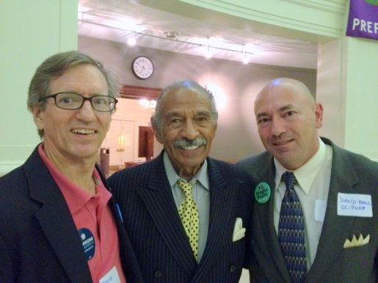
Keely and Ball had a productive conversation with Congressman John Conyers. The Representative was quite pleased to learn that a South Carolina chapter of PNHP had been established. He agreed to shoot a short promotional video that we can post on our upcoming web site. We asked for something brief uploaded to YouTube (that we could link to), which welcomes those that view the site to PNHP and Health Care for All – South Carolina, perhaps 30 seconds to three minutes in length. A follow up letter requesting the support was sent to his staff. Will check next month on the status of the request.

