September 2013

INSIDE – The next meeting of Healthcare for All – SC has been rescheduled from Oct 8th to Nov 5th in Florence to permit more time for planning. Diane Shrader in consultation with Dave Keely has been hard at work outlining the event. The follow on meeting will take place in the Columbia area and be coordinated by Midlands Ambassador Emilio Perez.

The workshop proposal to create legislation at the state level for the Oct 5-6 Healthcare-NOW! conference in Nashville TN was accepted. PNHP will team up with Public Citizen to draft model legislation tailored to the states that activists attending represent.

OUTSIDE –

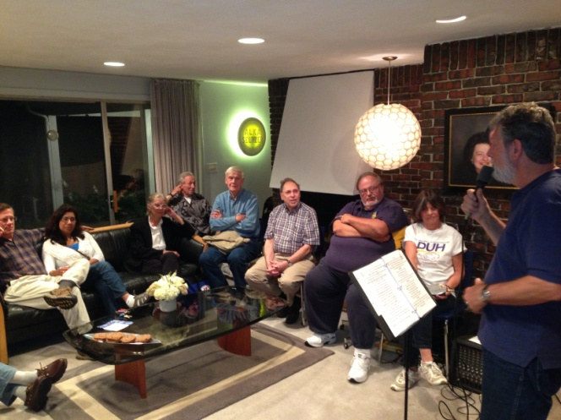
Drive for Universal Healthcare (DUH), in collaboration with PNHP held a screening of The Healthcare Movie in Natick MA Sept 6th at the parents of David Ball when the Boston venue became unavailable. Sue Saltmarsh, the Founder of DUH, along with Donna Ellington, the Charleston-based media director for DUH who assisted Healthcare for All – SC in showing the movie in Charleston were on hand. The man with the microphone is Bob Wickline, a singer/songwriter traveling the country promoting Universal Health Care. Short clips of TV and radio ads he has produced have been added to our website.

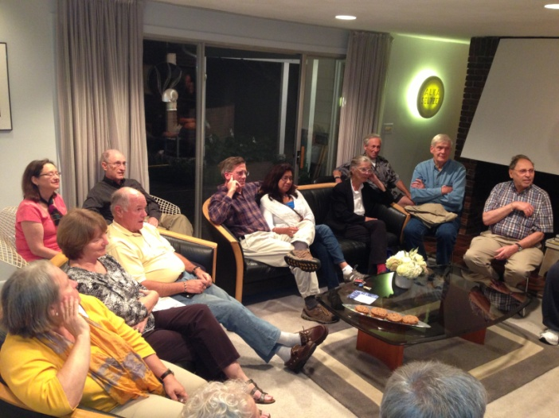

In the second photo on the left in the back are Laurie Simons and Terry Sterrenberg, husband and wife social workers who created the movie that chronicles the struggle of Tommy Douglas to bring Medicare to all Canadians. The film is narrated by his grandson, Kiefer Sutherland.

On September 18th Emilio Perez and David Ball attended a presentation at the College of Nursing at the University of South Carolina. Cosponsored by the College of Health Policy, College of Social Work, College of Pharmacy and the College of Medicine this well attended event consisted of the screening of the film Escape Fire followed by a panel discussion with representatives of the various colleges.

The film’s title relates to an incident when a team of smoke jumpers were trapped in a canyon by a raging forest fire. A member of the team intentionally set fire to an area near him in order to create a space where no new fire could start. He was able to survive in the burned out area while the remainder of the team perished trying to outrun the inferno. The challenge from the filmmakers is for us to come up with innovative solutions to keep healthcare costs from eating up alive.

Much of the movie focused on compelling statistics which should galvanize us all into action. It showed, for example, that while high tech treatments and procedures contribute substantially in increases in healthcare costs only 1 in 16,000 Americans per year have had their lives saved or extended by advances in healthcare technology.

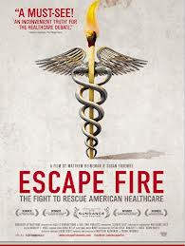
Unfortunately, while the film does an excellent job of highlighting the “disease-care management system” it prescribes few answers. It hints that the way physicians are trained and the industry is incentivized need to be radically altered. This leaves the viewer feeling overwhelmed and powerless. In contrast, as part of the excellent study guide which accompanies the movie, the producers challenge the audience to “make a difference by next Tuesday”.

Posing the first question during panel time HFA – SC asked whether the participants would support a bill which resulted in health care coverage for all Americans without copay, deductible, or exclusion without raising taxes. The economist on the panel gave a nervous laugh before replying, “Well sure, if we could get that who wouldn’t want it?” Sometimes the way to escape fire (healthcare costs) is right in front of our nose (Medicare).

We did get the opportunity to present (2-3 minutes) Single Payer although we were not able to become panelists. Several folks approached us after the event to talk including the issues director for the Charleston area LWV and Terri Jowers, Campaign Director for Healthy Columbia, a community organizing group to improve health care based in Columbia. We plan to work with both in the future.

