May 2013
In late April Dave Keely visited the State House in Columbia. There remained hope that 6 Republican legislators might break ranks and enable Medicaid Expansion to be included in the upcoming budget. The optimism proved unfounded.

SC Alliance for Retired Americans Board meeting / SC Alliance for Retired Americans, Midlands District meeting, Columbia, SC, April 30th -- Dave Keely met with Donna Dewitt, Brett Bursey, and others to further solidify HFA-SC's partnership efforts on single-payer and on the SC Medicaid expansion efforts. Of note, SC ARA Board members said that the lobbying effort for SC Medicaid expansion in 2013 was not "strong enough" (despite the SC Hospital Association's involvement) and should be re-thought for 2014.

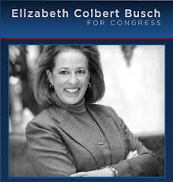
David Ball left the Medical University of South Carolina to work on the 1st Congressional District race for the US House of Representatives and to spend more time on Single Payer advocacy. As the personal driver for Elizabeth Colbert Busch he had plenty of time to discuss health care financing with the candidate. While Busch was up by nine points in the polls a week before the Special Election she was defeated by former Governor Mark Sanford. He had previously held the congressional seat for two terms before becoming governor.

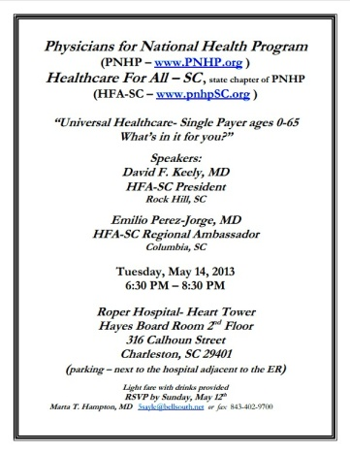
INSIDE – Dr. Marta Hampton and Respiratory Therapist Jason Gregory hosted the May 14th HFA-SC meeting held at Roper Hospital. This was the first gathering put together in Charleston. Thirteen members attended the event with Drs. Keely and Perez-Jorge acting as the speakers. Attendees reported the slide presentation was well done and the subsequent wide ranging discussion was stimulating.

Now that the Midlands has regular support the Steering Committee is focused on encouraging a regular presence in the Low Country. It was encouraging to see several members volunteer to organize the May meeting. This included securing the meeting location, providing refreshments, and contacting those in the Charleston area who have previously expressed an interest in Single Payer legislation.

OUTSIDE – Rock Hill Progressive Network, Rock Hill, May 8th -- Dave Keely met with and spoke to about 8 local York County Progressive Network activists about SC Medicaid expansion as a needed, and logical, "stepping stone" to single-payer, universal health care system reform in our country. Lively discussion ensued, and as a result a nucleus of single-payer system "group support" was affirmed in York County!

Health Care Justice - North Carolina launch in Charlotte, May 23rd -- Charlotte-area family physician Jessica Saxe moderated, and PNHP national speaker, Dr. Gerald Friedman (health economist at U-Mass Amherst), made a strong "economic argument" for the single-payer "solution" as the only "sustainable" US healthcare system reform strategy. HFA-SC President Dave Keely delivered a formal greeting to the large gathering, with expressed interest in partnering for stronger dual-state advocacy of single-payer, universal health care system reform through US Congress Bill H.R. 676.

As a consequence of participating in the Busch campaign we were able to make contact with Congressman Jim Clyburn’s staff. We are trying to get the Congressman to cosponsor HR 676 as he has in the past. We also spoke to State Senator David Mack who has a weekly radio show. He agreed to host a program on Single Payer several weeks from now.

After repeated failed attempts we finally met with the Health reporter for the Post and Courier. This gave us the opportunity to educate her on health care finance and PNHP. We offered to act as a resource on the topic and feel our access to the South’s oldest newspaper has been improved.

AMBASSADORS – Midlands Ambassador Emilio Perez-Jorge was the guest speaker in Charleston for the May 14th event. He continues to provide strong support to our chapter. While several individuals helped to ensure the Low Country meeting went well no Ambassador has yet been identified.

